Evaluation Worksheets

Introduction

This Evaluation Worksheet provides clinicians, suppliers and consumers with an outline of the evaluation process to determine medical justification for a standing device and to determine the
most appropriate option to meet an individual's needs. Clinicians and suppliers are encouraged to review related information contained in the NCART Standing Device Funding Guide.

Standing devices can be a standalone piece of equipment or may be incorporated into a manual or power wheelchair base. This evaluation worksheet can be used when considering the prescription of any type of standing device, but it does NOT replace the letter of medical necessity (LMN). The
information in this evaluation worksheet will help the clinician collect data that can then be used to write the detailed LMN for the consumer. Remember, this evaluation worksheet does NOT replace the letter of medical necessity.

All appropriate medical professionals involved in the consumer's care as it relates to standing should sign the LMN. Examples include: Physiatry (Rehabilitation Medicine), Neurology,
Orthopedics, Cardiology, Urology, Primary Care, Occupational Therapy, Physical Therapy, Speech Language Pathology, Psychology, etc.

- Consumer Data

Consumer Information
Name:
Address: City, State, Zip:
Home phone: Work phone: Social security #:
Date of birth:

Parent/Guardian
Name: Address: City, State, Zip: Home phone: Work phone:

www.easystand.com page 8

NCART Standing Device Evaluation Worksheet

Primary Funding Source

Name: ID #: Group #: Claims phone: Case manager:

Secondary Funding Source
Name:
ID #: Group #: Claims phone: Case manager:

Consumer's Employment/School Information
Employer/school: Address: City, State, Zip: Title/Grade: Supervisor/educator:

- Physical Findings

Diagnosis/Prognosis: Sex: Height: Weight: Onset of disability Medical history:

Chief complaints/Presenting problems:

page 9
www.easystand.com

Functional Status:
Ambulation: None Wheelchair for mobility Limited- Device used:

Walking Distance:
Mild assist Moderate assist Maximum assist
Transfer: Independent Dependent- One person assist Two person assist
Method: Activities of daily living: Independent Partial assist Dependent
Living environment: Home Apartment Institution Single level Multi-level
Owns Rents
Transportation: Car Van Public transportation Other Cognitive level: On age Level Delayed/Impaired
Understands safety of self & others Developmental/Psycho-Social need for standing
Comments: Communication: Verbal Non-verbal Augmentative Communication- Device

Comments:

Physical Status:
Sitting Balance: Good- hands free capability to weight shift Fair- hands free only
Poor- propped & hand support Dependent- needs external support Muscle Strength: U/E Normal Reduced None
L/E Normal Reduced None Sitting Posture (unsupported):
Posterior pelvic tilt: None Fixed Flexible Other Anterior pelvic tilt: None Fixed Flexible Other Pelvic obliquity: None Fixed Flexible Other Pelvic rotation: None Fixed Flexible Other Kyphosis: None Fixed Flexible Other Lordosis: None Fixed Flexible Other Scoliosis: None Fixed Flexible Other Head/neck hyperextension: None Fixed Flexible Other
Leg abduction: None Fixed Flexible Other Leg adduction: None Fixed Flexible Other

Wind sweeping: None Fixed Flexible Other Leg length discrepancy: None Left- inches Right- inches

Other: Lower extremity range of motion (seated):
Hip flexion (normal 0° to 125°): Left- degrees Right- degrees Knee extension hip at 90°: Left- degrees Right- degrees Ankle dorsi-flexion: Left- degrees Right- degrees
Other (e.g. hip subluxation, ankle inversion/eversion, orthotics used, etc.)
Tonal influences/reflexes:
Hypotonia Hypertonia Extensor Flexor ATNR STNR Positive support
Ankle clonus Other
Skin integrity: Intact Red area Open area Scar tissue History of pressure ulcers
Area: Ischial tuberosity Coccyx Spine Other
Sensation: Normal Impaired Non-sensate Level Bowel: Continent Incontinent Training Constipation Irregularity Other
Bladder: Continent Incontinent Training Current/history of UTI Kidney Stones
Other

Standing Status:
Description of ability to stand/bear weight-

Would this be an Initial or Replacement standing device- Initial Replacement

If item is Replacement:
Current stander and when obtained- Issues with current stander requiring replacement-

Is individual on a current standing program- Yes No If yes, describe results:

Therapies Received: PT OT Speech Other Other notes:

Measurements in Sitting & Standing (see diagram)

1. Seat surface (the contact point of the buttocks to) or Standing:

 | Left | Right | Standing
a. PSIS
b. Elbow
c. Inferior Scapula Angle
d. Axilla (Armpit)
e. Top of Shoulder
f. Top of Head

2. Trunk depth (back surface to front of the ribs) 3. Seat depth/thigh length (back surface to popliteal angle of knee) 4. Back of knee to heel (or weight-bearing area) 5. Foot length (with shoes & AFO's if applicable) 6. Trunk width (across chest)
7. Shoulder width
8. Hip width 9. Outer knee width (relaxed, with knees apart)
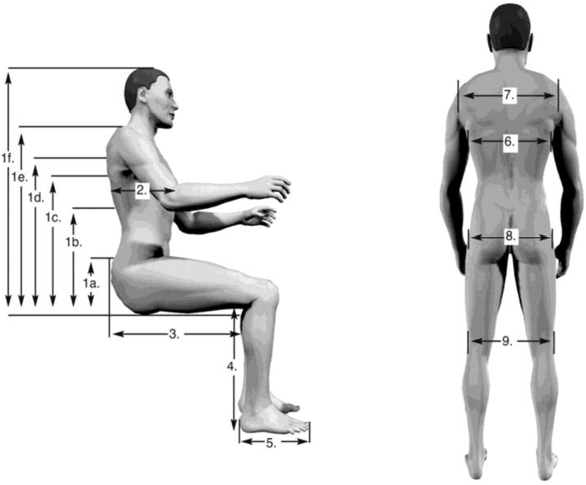

- Standing Device(s) Considered

Document each standing device considered in the areas below and list why it was ruled out or
why it is being chosen for the consumer.

Single Position Standing Frame System (E0638)
*Note: Position of use may be prone OR supine OR upright.
Pertinent Findings:

Transfer method: independent one-person two-person patient lift required

Sit-to-Stand System (E0637)
*Note: Position of use transitions consumer between sitting and standing to upright.
Pertinent Findings:

Transfer method: independent one-person two-person patient lift required

Multi-Position Standing Frame System (E0641)
*Note: Single device can be utilized in any ONE of these three positions: prone/supine/upright.
Pertinent Findings:

Transfer method: independent one-person two-person patient lift required

Mobile Standing Frame System (E0642)
*Note: Any of the above standing systems with the addition of a mobile option.
Pertinent Findings:

Transfer method: independent one-person two-person patient lift required

Manual Wheelchair Accessory, Manual Standing System (E2230)
*Note: Manual standing feature, which is part of a manual wheelchair base (accessory).
Pertinent Findings:

Transfer method: independent one-person two-person patient lift required

Power Wheelchair Accessory, Power Standing System (E2301)
*Note: Power standing feature, which is part of a power wheelchair base (accessory).
Pertinent Findings:

Transfer method: independent one-person two-person patient lift required

Other Standing Device: Pertinent Findings:

Transfer method: independent one-person two-person patient lift required

Standing Device Recommended

Type of stander needed: Manufacturer/Model:
Trial Date:

Considerations and Outcomes of Standing Device Trial

1. Does the consumer have consistent access to the device (including transfer considerations and care giver availability)? yEs NO

2. Is the patient able to operate the stander independently? yEs NO

3. Does the stander have adequate supports, anteriorly, posteriorly, and laterally to position the person in a symmetrical aligned standing? YES NO

4. What support and alignment options/accessories are necessary to properly position the
consumer?

5. Does the stander have enough adjustment to allow for individual fit and allow for growth or
body changes? YES NO

6. Is this stander appropriate for the client's home environment or the environments in which it will be used? YES NO

7. Did the consumer remain medically stable throughout the trial? YES NO

8. Additional comments to justify standing device type:

VI. Summary

A standing device is being recommended for the following reasons (check those applicable):
___Improve/Maintain range of motion: Current Issue At risk
Decrease joint/muscle contractures: Current Issue At risk
Management of atrophy in the trunk and leg muscles: Current Issue At risk
Improve strength to trunk and lower extremities: Current Issue At risk
Decrease muscle spasms: Current Issue At risk
Improve/Maintain bone integrity/skeletal development: Current Issue At risk
Lessen/Manage the progression of scoliosis: Current Issue At risk
Manage pressure (ulcers) through changing positions: Current Issue At risk

Improve bowel function and regularity: Current Issue At risk
Aid in kidney and bladder functions: Current Issue At risk
Strengthen cardiovascular system and build endurance: Current Issue At risk
Improve circulation: Current Issue At risk
Reduce swelling in lower extremities: Current Issue At risk
Improve independence with activities of daily living: Current Issue At risk
Improve cognitive and psycho-social: Current Issue At risk

Standing program recommendations (incl. frequency/duration):

Describe in detail the current problems and associated costs this consumer may be having due to the absence of the standing program listed above:

Evaluation completed by: Title: Phone: Facility: Address: Signature:

Date:

This Evaluation Worksheet was developed by the National Coalition for Assistive and Rehab Technology (NCART) Standing Device Workgroup. NCART seeks to ensure that
individuals with disabilities have appropriate access to complex rehab technology (CRT) and
related services. For additional information regarding CRT visit www.ncart.us.

